BRAC University
Department of Computer Science and Engineering

Spring – 2007
CSE110 (Programming Language-I )
Lab 10

Task 1
Create a class called Student as described below:
- Fields:
name, id, address, cgpa
- Methods:
public String getName()
public void setName(String n)
public String getID()
public void setID(String i)
public String getAddress()
public void setAddress(String a)
public double getCGPA()
public void setCGPA(double c)
Write a class called StudentTester to write a main() method:
- public static void main(String[] args){
}
- Inside the main() method
  - Create 3 objects/instances of Student called john, mike and carol
  - Set their fields to some value using the public methods.
  - Print the information of each Student using System.out.println()
Task 2
In mathematics, the Fibonacci numbers form a sequence defined by the following recurrence relation:

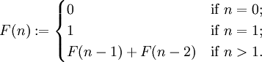

That is, after two starting values, each number is the sum of the two preceding numbers. The first Fibonacci numbers, also denoted as Fn, for n = 0, 1, … , are:

0, 1, 1, 2, 3, 5, 8, 13, 21, 34, 55, 89, 144, 233,

Write a complete Java program, which prints all Fibonacci numbers that are less than 1600.

